Screenshot of Output (Eclipse IDE)

Question

1)

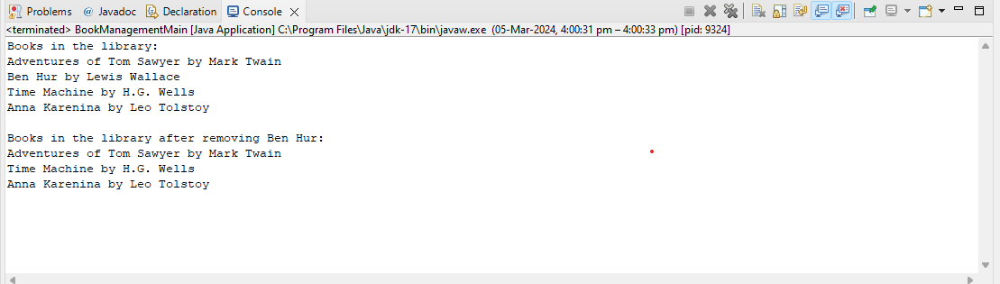

2) calculate employee salary (income tax )

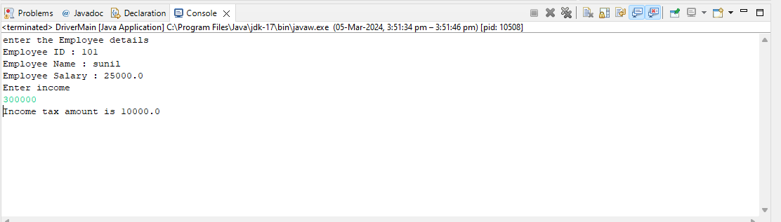

Calculate product price(sales tax)

